This guide will teach you how to add a ‘Firm Mission Statement’ to your ‘Mission Statement’ widget on our PBM home page. The purpose of the firm mission statement, is to provide a brief overview of what your firm is trying to accomplish with its pro bono department. While also imparting information on how to best contact the Pro Bono Team at your firm.
You can access the mission statement from the ‘Mission Statement’ widget on the PBM home page.
Mission Statement Widget – Home Page
Specified Area: Adding a Mission Statement

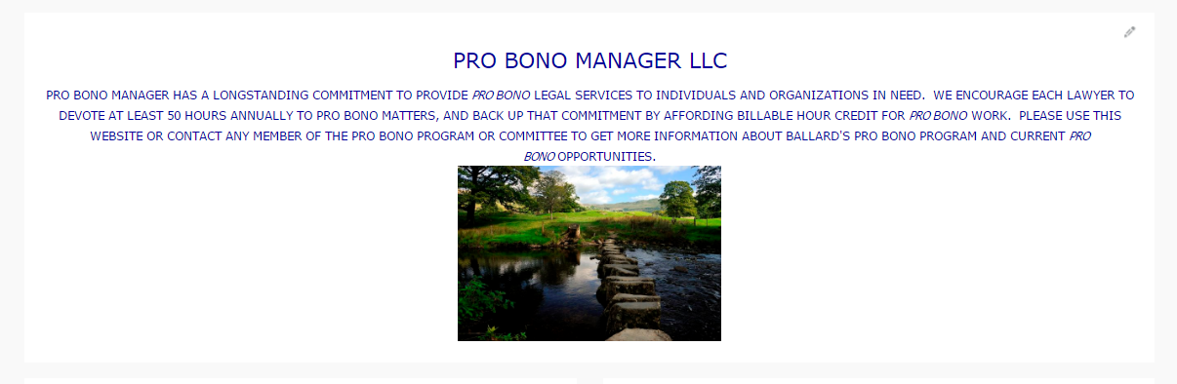
Within the new Pro Bono Manager system you will easily be able to access and change your Pro Bono Mission Statement. Shown above is a brief example of the type of information that you can place into the widget. This guide will give you step by step instructions on how to add/edit your information.

Step 1. Click the pencil icon in the top right corner of the widget (image below):
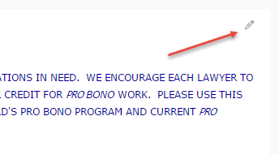

Once you click the pencil icon, this will open the Rich text editor box where you can make changes.

Step 2. Add text and images to provide information to the user base.
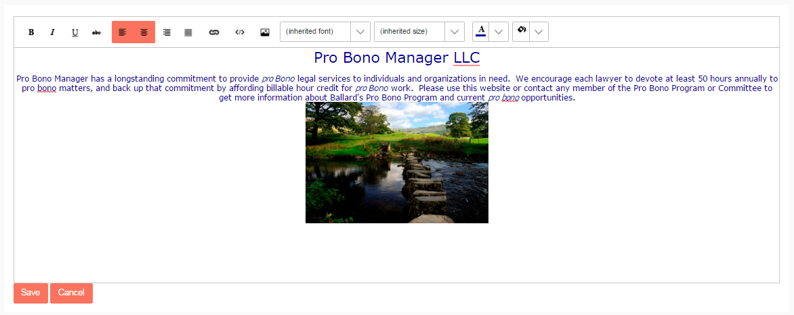
Within this widget you will have a large array of functionality. A comprehensive list is shown below:
- Font type
  - Functionality to choose from a short list of different fonts
- Font weight 
  - Functionality to create different types of effects on the text such as: Bold, Italics, Underline, and strikethrough.
- Font Size
  - Functionality to change the font size
- Font Color
  - Functionality to choose from a large scale color palette
- Font Background Color
  - Functionality to choose a highlight color from a large scale color palette
- Left, Right, Center, alignment for text and images
  - Functionality to choose your text alignment
- Linking
  - Functionality to easily link text within the mission statement – You can do this by highlighting a specific piece of text. You can then click the link button shown above, enter the URL you wish to link and a tooltip if necessary. Lastly you will have the ability to click a checkbox to have it open automatically in a new window.
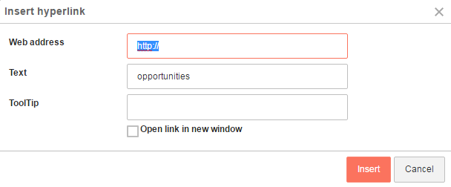
- Add image
  - Functionality to add images into your mission statement
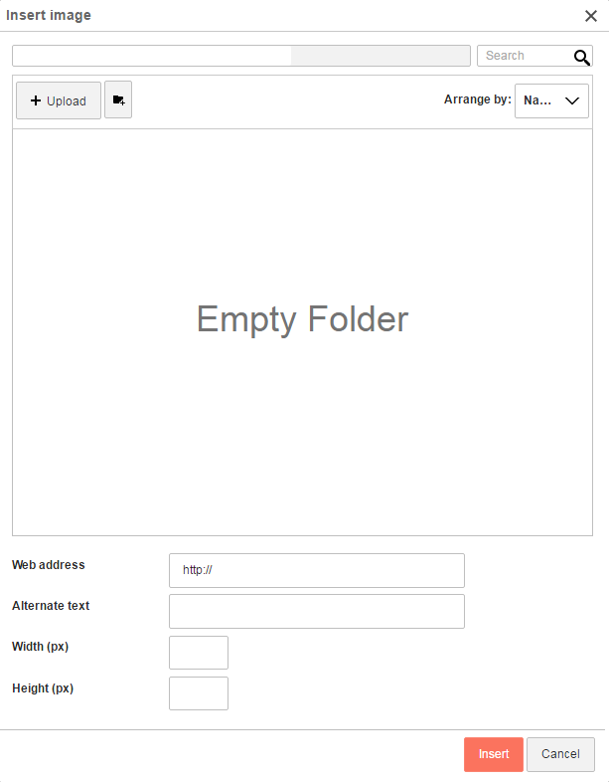
Adding an image can be done with a few simple steps.
- Click the add image icon
- Click the upload button
- Select the image you wish to upload
- Image will be uploaded to the section shown above
- Select the image and click insert
    - Within the Insert Image pop up you will have a few extra options as well
      - You can add the image by just entering the web address of the image
      - You can add Alternate text
      - You can also add in the Width and Height for how large or small you would like the image to be. This is done by using pixel numbers. (Common size – 200 x 200)
- HTML Editor
  - Within the HTML editor, you can directly change and edit the source code for the text and images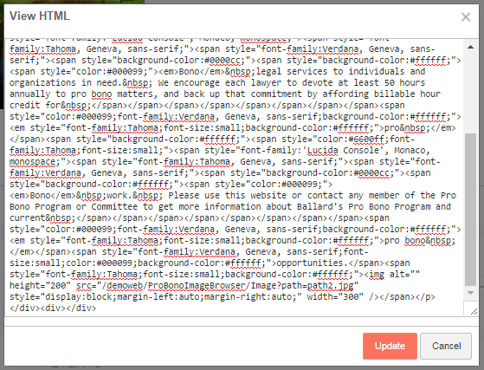
Step 3. Review the information you have inputted and click save. You will then be able to view the information right on the home page. If edits need to be made just follow the same steps from above.
