This guide will teach you how to add, edit and delete helpful links. Helpful links are internal or external links provided to your user base to access different types of information. They are listed in 4 different sections that will be explained below.
You can access Helpful Links from two different locations, your firm home page, and the resource library. Being able to add edit and delete these links will all be done from the resource library page. The resource library can be accessed through the left hand navigation item, or by clicking View More Helpful Links in the Helpful Links widget on the home page.
Helpful Links
Adding a Helpful Link
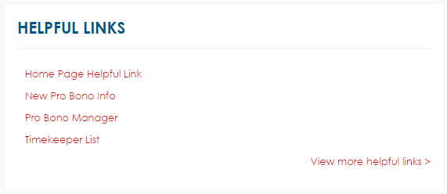
On your firm home page you will be able to view helpful links that are associated to the home page as shown above! A full list of other Helpful Links will be seen when you click on the View more helpful links button
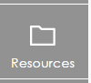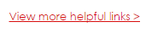
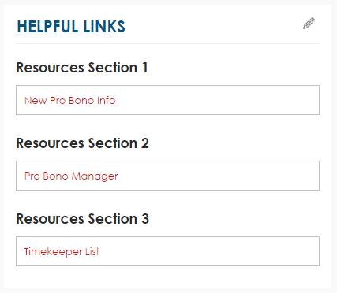
Step 1. Click the View more helpful links button to access the resource library. Alternatively you can click the Resource library icon in the left hand navigation. Within the Helpful Links widget on the resource library you will see 3 different section headers. These headers are customizable by your PBM admins. Please ask if you would like them changed. (support@pbm.com)
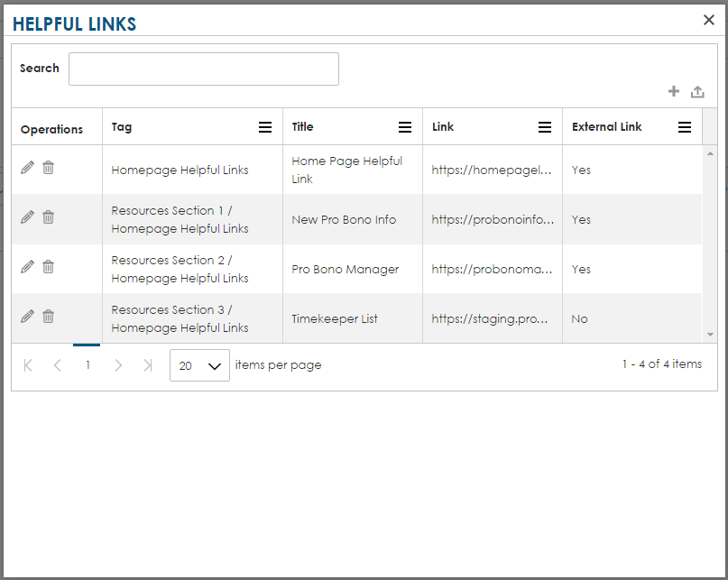
Step 2. Click the pencil icon on the Helpful links widget. This will open the Helpful Links grid. Within this grid you can see a full list of helpful links that have been added.
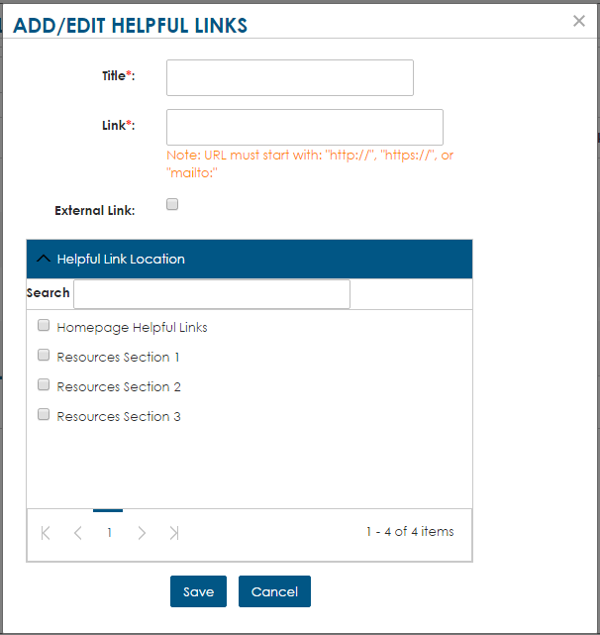
Step 3. Click the plus icon within the grid to open the Add/Edit Helpful Links pop up – below is a list of items to fill out on the helpful links widget.
- Title* 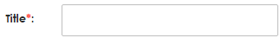
  - The title is the link that will show within the grid and widget
- Link* 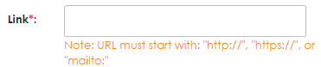
  - The link is the internal or external link that the title refers to
- External Link Checkbox 
  - By checking or unchecking this you list that the link is either internal (from your firm intranet) or external (an open web link for the public)
- Helpful Link Location
  - In this section you select where the link will be displayed. If you select Homepage Helpful links the link will show on your firm homepage. If you select one of the other three sections it will only show in that section on the resource library. You can select more than one section for it to show. EXAMPLE: Select Homepage helpful link and Resources Section 1
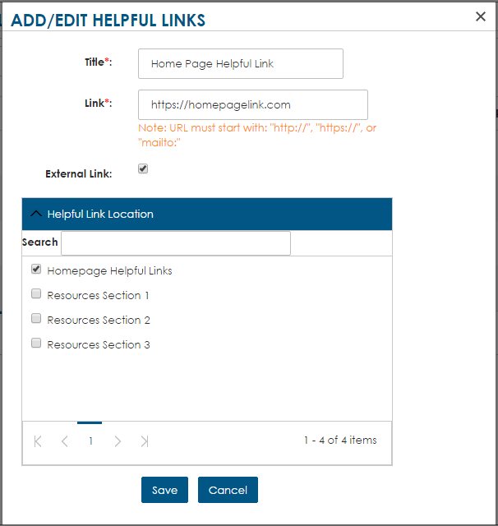
Step 4. After filling out all of you information you can click save or cancel. When you click save the item will show up within the grid. After a page refresh you will be able to see the item within the widget display

Helpful Links
Editing a Helpful Link

Step 1. Click the View more helpful links button to access the resource library. Alternatively you can click the Resource library icon in the left hand navigation. Within the Helpful Links widget on the resource library you will see 3 different section headers. These headers are customizable by your PBM admins. Please ask if you would like them changed. (support@pbm.com)
Step 2. Click the pencil icon on the Helpful links widget. This will open the Helpful Links grid. Within this grid you can see a full list of helpful links that have been added.
Step 3. Edit the information within the Add/Edit Helpful Links pop up
Step 4. Click save or cancel and see the updated changed within the grid
Helpful Links
Deleting a Helpful Link

Step 1. Click the View more helpful links button to access the resource library. Alternatively you can click the Resource library icon in the left hand navigation. Within the Helpful Links widget on the resource library you will see 3 different section headers. These headers are customizable by your PBM admins. Please ask if you would like them changed. (support@pbm.com)
Step 2. Click the pencil icon on the Helpful links widget. This will open the Helpful Links grid. Within this grid you can see a full list of helpful links that have been added.
Step 3. Within the grid click the garbage can icon next to the link you would like to delete. This will bring up a pop up asking you if you are sure you would like to delete the item. Click OK and the item will be deleted.

