This guide will teach you how to add and edit News Items within your Pro Bono Manager site. News Items are used to provide information to your timekeepers about upcoming events in their area.
You can access the add and edit screens in a couple of different fashions. You can get to the add screen by selecting the plus sign on the News Item List page. You can access the edit page by selecting the pencil icon on the News Item page.
News Items
Specified Area: Adding a News Item

Step 1. Click the view all button on the news list on your PBM Home page.

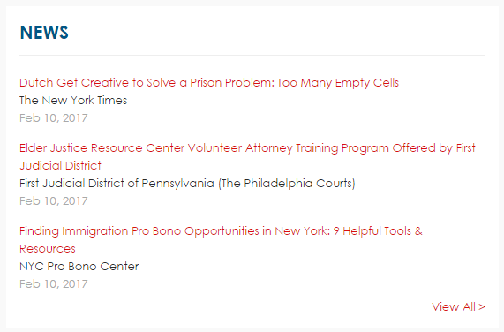
Step 2. Click the plus icon on the grid to add a new
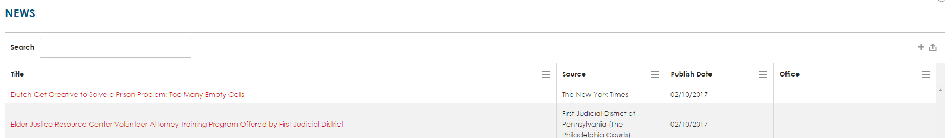

Step 3. After selecting the plus icon a pop up will show (image below). This pop up will be a full form to fill out your new News Item! A full list of editable fields will show, the fields are indicated below (NOTE: Field with a * are required):
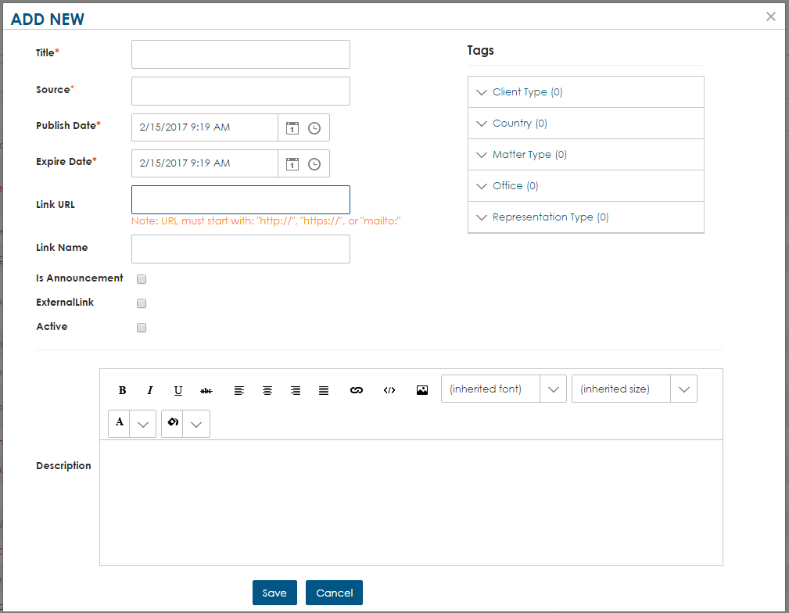
- Title*
  - This will show the title of your event.
- Source*
  - This will show the host(s) name.
- Publish Date* 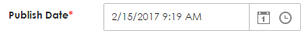
  - This will show the start date and time of the event.
- Expire Date* 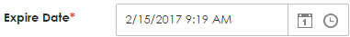
  - This will show the end date and time of the event.
- Link URL
  - This will show the Linked URL for the event. (NOTE: URL must start with: https://, http://, or mailto:)
- Link Name
  - This will be the words that the link URL will be placed into.
- Link is External
  - By selecting this option you will be saying that the link is outside of PBM.
- Special Announcement 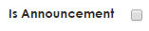
  - By selecting this option you will be showing that this event is also a special announcement. Which means it will show in the Special Announcements widget on the homepage.
- Active
  - By selecting this option you will be showing that the event is active.
- Description
  - To view additional information on how to use the rich text editor. Please view this article.
- Add News Item Tags – Tagging (see link on how to tag)
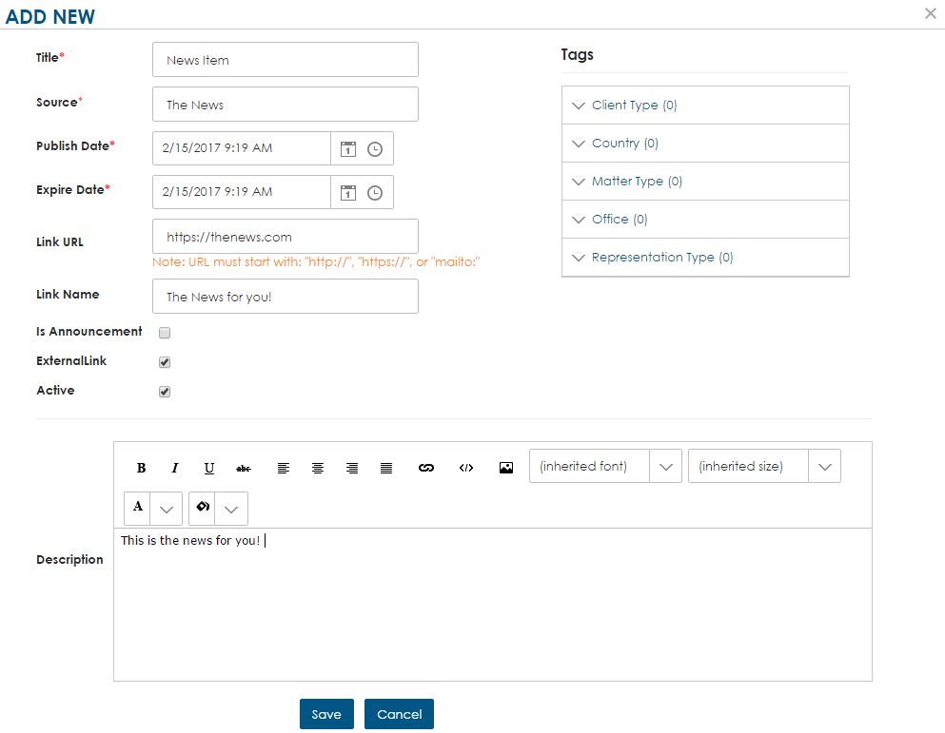
Step 4. After you have filled out the form and reviewed the data, you can click submit at the bottom of the page! You have now added a new News Item.
News Items
Specified Area: Editing a News Item

Step 1. Click the view all button on the events list on your PBM home page.

Step 2. Select from the grid the event you would like to edit. This will open up the Event Details page. On this page you will be able to click the pencil icon.
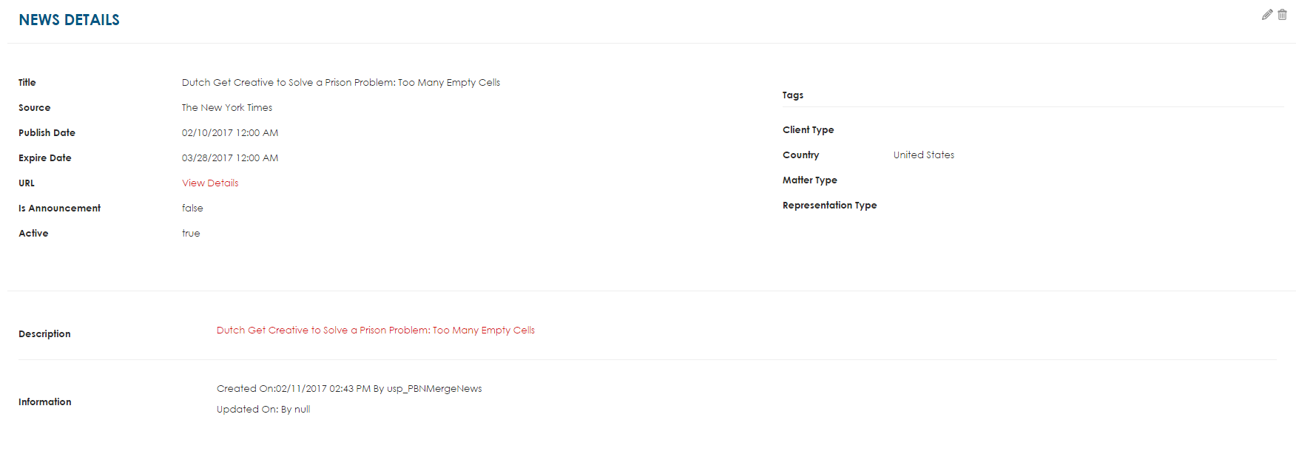

Step 3. After selecting the pencil icon a pop up will show. This pop up will be a full form to edit a News Item!

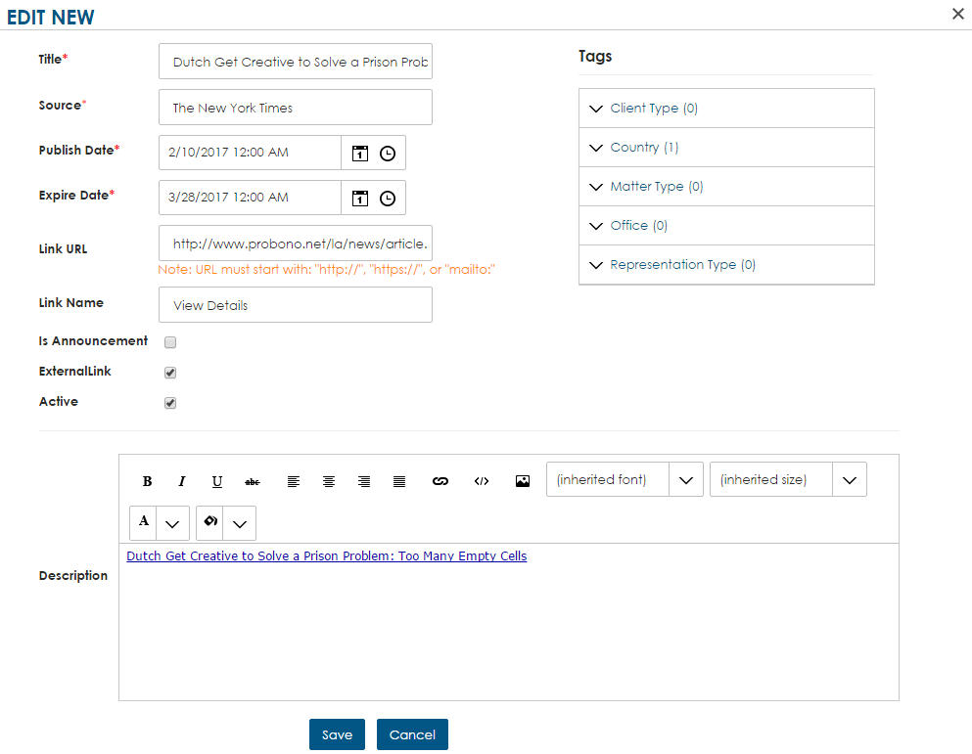
Step 4. After you have edited the form and reviewed the data, you can click save at the bottom of the page.
News Items
Deleting a News Item

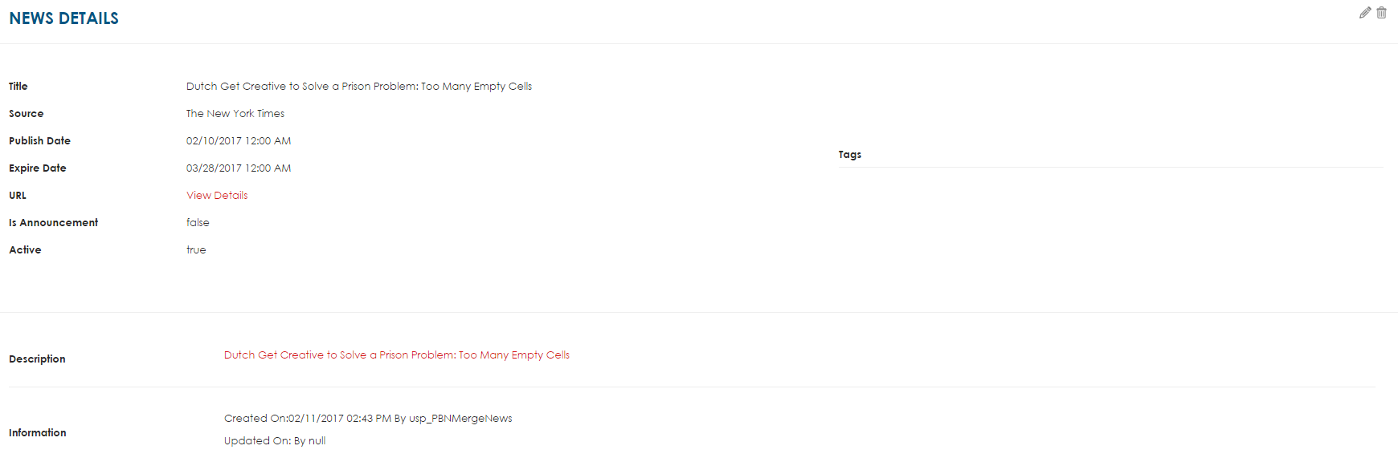

Step 1. Access the Event Details Page by selecting a news item from the Grid

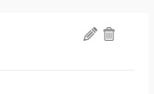

Step 2. Click the Garbage can in the top right corner of the details page – A pop up will ask you if you really want to delete the news item. Once you click yes the news item will be deleted

